DCC-GARCH correlation: NZDUSD and EURGBP
Method 09 / GARCH(1,1) + Engle DCC / Alpari D1 full available history

Study setup
Logical pair: NZDUSD , EURGBP
Broker symbols: NZDUSD_i , EURGBP_i
Snapshot: 2026-11-03_majors_alpari_D1
Timeframe: D1
Matched return window: 1999-01-06 to 2026-11-02 (UTC bar dates)
Matched return count n: 7183
Dropped unfinished last bar dated 2026-11-03 UTC after a tick-volume check against the prior complete day.
NZDUSD GARCH(1,1): mu=0.000000, omega=0.004923, alpha=0.040784, beta=0.950246
EURGBP GARCH(1,1): mu=-0.000019, omega=0.000668, alpha=0.046768, beta=0.951531
DCC: a=0.009358, b=0.988547, a+b=0.997905
Burn-in ignored in path summaries and chart: first 60 updates
Complete matched rows (Excel): NZDUSD-EURGBP_DCC_D1.xlsx
Complete matched rows (HTML table): NZDUSD-EURGBP_DCC_D1_data.html

Method carried forward
DCC-GARCH first fits a constant-mean GARCH(1,1) on each matched daily log return of close, ln(close_t / close_t-1), then updates Engle (2002) dynamic conditional correlation on the standardised shocks z = residual / conditional sigma. Quotes are not inverted. Correlation targeting sets Q_bar to the sample correlation of z; a and b are estimated by maximising the bivariate Gaussian DCC likelihood with a >= 0, b >= 0, and a + b < 1. Path summaries ignore the first 60 updates. The headline is rho on the last day. Same-sample Pearson r on log returns is a side check only. A high |rho| does not prove cause, lead-lag, or a trading signal.

Results
Latest DCC rho: -0.114054
Post-burn-in path (n=7123): mean=0.033447, median=0.038731, min=-0.299880, max=0.413272, std=0.147222
Share of post-burn-in days with |rho| >= 0.4: 0.06%; |rho| >= 0.7: 0.00%
Same-sample Pearson r: 0.037186
Latest rho minus r: -0.151241

Conclusion
Over 7183 matched daily log-return rows for NZDUSD and EURGBP (broker quote directions unchanged), latest DCC rho is -0.1141 (negative, weak conditional linear link in this sample) with fitted a=0.0094, b=0.9885 (a+b=0.9979). After a 60-day burn-in, path mean is 0.0334 and std is 0.1472. Same-sample Pearson r is 0.0372 (latest rho minus r = -0.1512). This does not establish cause, lead-lag, or a lasting trading rule.

Charts
Daily closes

Daily log returns
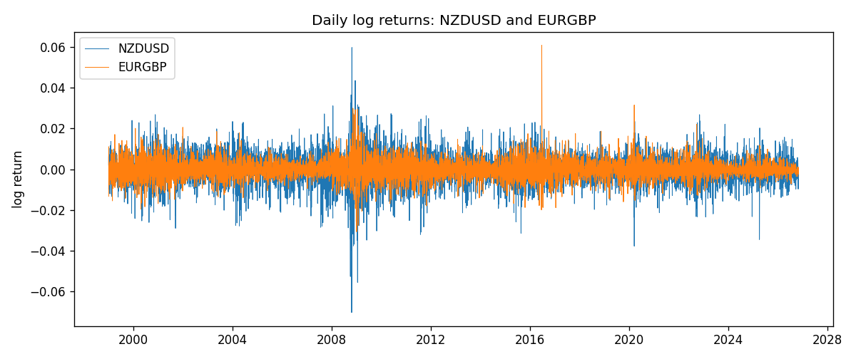
DCC rho path with Pearson r reference
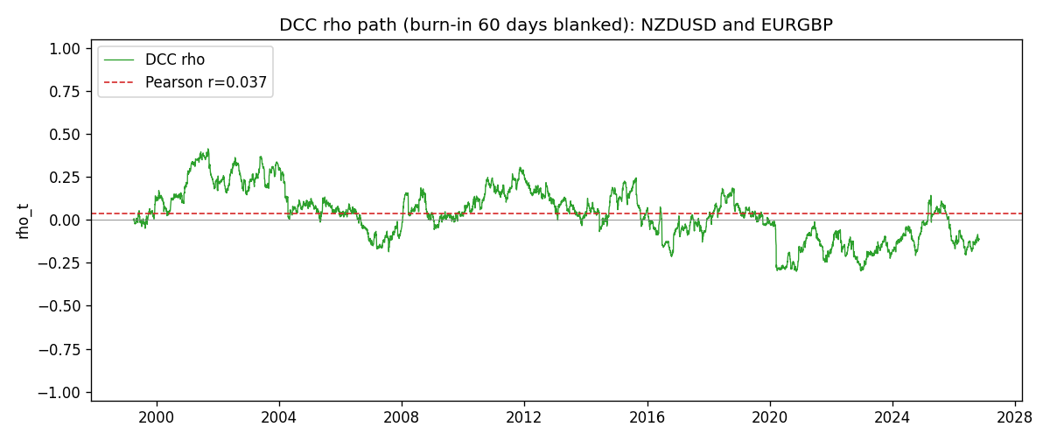

Data report
Every matched row that entered the DCC recursion is stored in the sibling Excel workbook named NZDUSD-EURGBP_DCC_D1.xlsx. Embedding all rows as a Word table is impractical at this length; the Word file holds the column list, column summaries, and the first and last 15 matched rows.
Columns: time, NZDUSD_open, EURGBP_open, NZDUSD_high, EURGBP_high, NZDUSD_low, EURGBP_low, NZDUSD_close, EURGBP_close, NZDUSD_tick_volume, EURGBP_tick_volume, NZDUSD_spread, EURGBP_spread, NZDUSD_real_volume, EURGBP_real_volume, NZDUSD_log_return, EURGBP_log_return, NZDUSD_sigma, EURGBP_sigma, NZDUSD_z, EURGBP_z, q11, q22, q12, rho_t
Column summaries (matched calculation rows)
column | count | mean | std | min | 25% | 50% | 75% | max
NZDUSD_open | 7183 | 0.65646991 | 0.10818219 | 0.3913 | 0.591455 | 0.6684 | 0.72495 | 0.88218
EURGBP_open | 7183 | 0.78694248 | 0.0966971 | 0.5734 | 0.68755 | 0.83389 | 0.86522 | 0.9769
NZDUSD_high | 7183 | 0.66038812 | 0.10867344 | 0.3961 | 0.5949 | 0.67204 | 0.729365 | 0.88421
EURGBP_high | 7183 | 0.7900202 | 0.09707133 | 0.5789 | 0.6896 | 0.8369 | 0.8681 | 0.9799
NZDUSD_low | 7183 | 0.65278196 | 0.10777661 | 0.3897 | 0.58816 | 0.6642 | 0.720985 | 0.87988
EURGBP_low | 7183 | 0.78424251 | 0.0965143 | 0.5682 | 0.6855 | 0.83166 | 0.86287 | 0.9661
NZDUSD_close | 7183 | 0.65654354 | 0.10817679 | 0.3907 | 0.59181 | 0.6685 | 0.72502 | 0.8822
EURGBP_close | 7183 | 0.78698724 | 0.09669475 | 0.5735 | 0.68775 | 0.83395 | 0.86536 | 0.977
NZDUSD_tick_volume | 7183 | 68736.568 | 123152.54 | 16 | 5594.5 | 33901 | 58513.5 | 1127682
EURGBP_tick_volume | 7183 | 87133.158 | 145499.84 | 154 | 6553 | 44358 | 81413 | 1424684
NZDUSD_spread | 7183 | 30.260755 | 25.633067 | 0 | 9 | 17 | 40 | 80
EURGBP_spread | 7183 | 21.328832 | 19.122264 | 0 | 4 | 13 | 40 | 50
NZDUSD_real_volume | 7183 | 1.6708354e+10 | 8.49951e+10 | 0 | 0 | 0 | 0 | 2.705649e+12
EURGBP_real_volume | 7183 | 2.7872287e+10 | 1.3521454e+11 | 0 | 0 | 0 | 0 | 3.5726265e+12
NZDUSD_log_return | 7183 | 1.073e-05 | 0.0076464 | -0.07027433 | -0.00425909 | 0.00022967 | 0.00458236 | 0.05966839
EURGBP_log_return | 7183 | 2.33e-05 | 0.00487088 | -0.03067367 | -0.00262163 | -9.879e-05 | 0.002558 | 0.06075387
NZDUSD_sigma | 7183 | 0.00728928 | 0.00217212 | 0.0043867 | 0.00595705 | 0.00670913 | 0.00804629 | 0.02525596
EURGBP_sigma | 7183 | 0.00463465 | 0.00169386 | 0.001859 | 0.00343265 | 0.00442133 | 0.00552139 | 0.01551095
NZDUSD_z | 7183 | -0.00191018 | 1.0000748 | -5.6204222 | -0.63001315 | 0.03308143 | 0.64713471 | 4.1973773
EURGBP_z | 7183 | 0.00790277 | 1.0000696 | -3.7945968 | -0.62259575 | -0.0197271 | 0.59734441 | 8.4770453
q11 | 7183 | 1.0022396 | 0.10823237 | 0.74416201 | 0.9287188 | 0.98563106 | 1.061799 | 1.6302202
q22 | 7183 | 1.0028609 | 0.10471929 | 0.75514693 | 0.93705892 | 0.99691439 | 1.0573171 | 1.8021582
q12 | 7183 | 0.03516087 | 0.14944619 | -0.39357593 | -0.06841912 | 0.03798116 | 0.13551162 | 0.41837813
rho_t | 7183 | 0.03336595 | 0.14662554 | -0.29988049 | -0.06980024 | 0.03837862 | 0.13108052 | 0.41327206
First 15 matched rows (selected columns)
time | NZDUSD_log_return | EURGBP_log_return | NZDUSD_sigma | EURGBP_sigma | NZDUSD_z | EURGBP_z | q11 | q22 | q12 | rho_t
1999-01-06 | 0.0020455609 | -0.013303338 | 0.0060261109 | 0.0056055506 | 0.33937399 | -2.3697682 | 1 | 1 | 0.03364493 | 0.03364493
1999-01-07 | 0.0062963171 | 0.011051402 | 0.0059304439 | 0.0061821237 | 1.0616172 | 1.7907898 | 0.99171978 | 1.0431948 | 0.025804004 | 0.025369383
1999-01-08 | -0.00055396548 | -0.004943862 | 0.0059606419 | 0.0064934656 | -0.093013653 | -0.75835924 | 0.99300338 | 1.0633526 | 0.043369809 | 0.042205933
1999-01-11 | 0.010290425 | -0.0012752393 | 0.0058537515 | 0.0064282433 | 1.7578419 | -0.19534993 | 0.98380645 | 1.0586508 | 0.043603673 | 0.042725964
1999-01-12 | -0.0053157489 | 0.0033970309 | 0.0061132839 | 0.0062817223 | -0.86961519 | 0.54388162 | 1.0035503 | 1.0489782 | 0.039961271 | 0.038948121
1999-01-13 | -0.0099742238 | 0.00042381861 | 0.0060957206 | 0.0061773917 | -1.6363413 | 0.071761841 | 1.0012284 | 1.0418274 | 0.035148036 | 0.034414114
1999-01-14 | -0.00018564931 | -0.0019793588 | 0.0063134145 | 0.0060321305 | -0.029477695 | -0.32490617 | 1.0169135 | 1.0320385 | 0.033717087 | 0.032912441
1999-01-15 | -0.00074294208 | -0.0076715819 | 0.0061943363 | 0.0059050351 | -0.12001248 | -1.2958601 | 1.0073699 | 1.0233014 | 0.033491037 | 0.032986203
1999-01-18 | -0.0018597736 | 0.00071280921 | 0.0060807591 | 0.0059987191 | -0.30592056 | 0.12207466 | 0.99806222 | 1.029391 | 0.034633303 | 0.034168423
1999-01-19 | 0.0018597736 | -0.0014261269 | 0.005980754 | 0.0058593852 | 0.31088355 | -0.24006691 | 0.98960218 | 1.0198358 | 0.033957657 | 0.03380199
1999-01-20 | 0.0040793678 | 0.0019960086 | 0.0058841382 | 0.0057295461 | 0.69320469 | 0.3517715 | 0.98126769 | 1.0107899 | 0.032940809 | 0.033075777
1999-01-21 | 0.0040627941 | -0.00071240297 | 0.0058370657 | 0.0056118959 | 0.6959556 | -0.12347353 | 0.97662104 | 1.0024663 | 0.034915974 | 0.035287934
1999-01-22 | -0.012051689 | -0.0017118406 | 0.0057915057 | 0.0054823535 | -2.0810037 | -0.30869192 | 0.97206338 | 0.9932227 | 0.033782412 | 0.034381122
1999-01-25 | -0.0035504102 | -0.0054402425 | 0.0061878222 | 0.0053665794 | -0.57384741 | -1.0100959 | 1.003551 | 0.98483403 | 0.03947748 | 0.039709844
1999-01-26 | 0.0072741158 | -0.00057438255 | 0.006114792 | 0.0053707846 | 1.1895188 | -0.10331827 | 0.99723387 | 0.98519763 | 0.044520122 | 0.044915492
Last 15 matched rows (selected columns)
time | NZDUSD_log_return | EURGBP_log_return | NZDUSD_sigma | EURGBP_sigma | NZDUSD_z | EURGBP_z | q11 | q22 | q12 | rho_t
2026-10-13 | 0.0047326165 | 0.00020130374 | 0.0049228265 | 0.0020187946 | 0.96126908 | 0.10936533 | 0.8274903 | 0.78006975 | -0.069902247 | -0.087004749
2026-10-14 | -0.0037306483 | 0.0011241873 | 0.0049430869 | 0.0019867284 | -0.75481252 | 0.57565479 | 0.82875523 | 0.77334255 | -0.06804735 | -0.084998668
2026-10-15 | 0.0047634855 | -0.00087557391 | 0.0049273235 | 0.0019707268 | 0.96665661 | -0.43440396 | 0.82669016 | 0.76968152 | -0.07126367 | -0.089339038
2026-10-16 | 0.0057501001 | -0.0020380844 | 0.0049485508 | 0.0019484898 | 1.1618845 | -1.0359828 | 0.82806145 | 0.76472729 | -0.074306602 | -0.093377624
2026-10-19 | 0.0018917133 | -0.00056950988 | 0.0050110254 | 0.0019672254 | 0.3774193 | -0.27959556 | 0.83330577 | 0.76810748 | -0.084649249 | -0.10580591
2026-10-20 | 0.0037199341 | -0.0035906254 | 0.0049496721 | 0.0019399396 | 0.75145959 | -1.8408527 | 0.82718993 | 0.76213691 | -0.08459676 | -0.10654538
2026-10-21 | 0.0030923331 | -0.00140647 | 0.0049332432 | 0.0020601464 | 0.62674338 | -0.6732471 | 0.82509553 | 0.78721507 | -0.096502571 | -0.11974022
2026-10-22 | -0.0033035227 | -0.0018743924 | 0.0048998222 | 0.0020482369 | -0.67430575 | -0.90561302 | 0.82141661 | 0.78453574 | -0.099275468 | -0.123667
2026-10-23 | 0.0030929853 | 0.00082421033 | 0.0048735309 | 0.0020541815 | 0.63455629 | 0.41071966 | 0.81835891 | 0.78532031 | -0.092353388 | -0.11520133
2026-10-26 | -0.0028993932 | 0.00013133309 | 0.0048427235 | 0.0020286064 | -0.59880535 | 0.074344378 | 0.81484937 | 0.77999965 | -0.088786226 | -0.11136782
2026-10-27 | -0.00026399852 | -0.0019957343 | 0.0048083721 | 0.0019959111 | -0.05499868 | -0.9901503 | 0.8109674 | 0.77321305 | -0.088115451 | -0.11127581
2026-10-28 | -0.0097283914 | 0.00066967224 | 0.0047397574 | 0.0020099866 | -2.0526044 | 0.34286529 | 0.8038027 | 0.77562704 | -0.08652615 | -0.10958376
2026-10-29 | 0.00062190714 | -0.0011722209 | 0.0050695319 | 0.0019832437 | 0.12258559 | -0.58123896 | 0.83611884 | 0.76993889 | -0.092050529 | -0.11472661
2026-10-30 | 0.00019537668 | -0.0024205543 | 0.004992951 | 0.0019676317 | 0.039039254 | -1.2202852 | 0.8287784 | 0.7663773 | -0.091592542 | -0.11492634
2026-11-02 | -0.0025962955 | 0.00089940465 | 0.0049176319 | 0.0020050835 | -0.5280491 | 0.45827868 | 0.82139567 | 0.77362999 | -0.090918834 | -0.11405413

